**DATE:06/08/2021 NAME:K.C.THAVASHANKARRAJA**

C++ LABORATORY PROGRAMS

### 1.a) 1. Develop C++ code to display the student details (Reno, Name, DOB, Dept, Phone number).

### AIM:

### To develop c++ code to display the student detail(Reno,Name,DOB,Dept,phone number)

### ALGORITHM:

### Step 1:create a structure with register number ,name, date of birth,phone number

### Step 2:get the number of students

### Step 3:declare the number of students as the array size for the structure variable

### Step 4:now get the details using for loop in each index of the structure variable

### Step 5:using another for loop print the details in the structure variable

### PROGRAM:

### #include<iostream>

### using namespace std;

### struct details{

### int regno;

### char name[20];

### char dob[10];

### char dept[5];

### unsigned long long number;

### 

### };

### int main()

### {

### cout<<"enter the number of students";

### int students;

### cin>>students;

### struct details a[students];

### for(int i=0;i<students;i++)

### {

### cout<<"enter register number";

### cin>>a[i].regno;

### cout<<"enter student name";

### cin>>a[i].name;

### cout<<"enter date of birth in dd/mm/yy format";

### cin>>a[i].dob;

### cout<<"enter the department";

### cin>>a[i].dept;

### cout<<"enter the number";

### cin>>a[i].number;

### }

### for(int i=0;i<students;i++)

### {

### cout<<a[i].regno;

### cout<<"\n";

### cout<<a[i].name;

### cout<<"\n";

### cout<<a[i].dob;

### cout<<"\n";

### cout<<a[i].dept;

### cout<<"\n";

### cout<<a[i].number;

### cout<<"\n";

### cout<<"\n";

### }

### return 0;

### }

### OUTPUT:

### 

### b)Develop C++ program to calculate gross salary for the conditions given below:

### AIM:

### To develop c++ program to calculate gross salary for the condition given below

### ALGORIHTM:

### Step 1:get the basic salary

### Step 2:using if else if divide the conditions accordingly

### Step 3:enter the calculations in the if else condition statements using formula given

### Step 4:if the condition is met print the gross salary accordingly

### PROGRAM:

### #include<iostream>

### using namespace std;

### int main()

### {

### float basicsalary, grosssalary, HRA, DA, Conveyance;

### cout<<"Enter your basic salary : ";

### cin>>basicsalary;

### if (basicsalary>=5000)

### {

### HRA=0.2*basicsalary;

### DA=1.1*basicsalary;

### Conveyance = 500;

### }

### else if(basicsalary>=3000 && basicsalary<5000)

### {

### HRA=0.15*basicsalary;

### DA=1*basicsalary;

### Conveyance = 400;

### }

### else

### {

### cout<<"Invalid Input";

### }

### grosssalary = basicsalary+HRA+DA+Conveyance;

### cout<<"Gross salary is : "<<grosssalary;

### 

### return 0;

### }

### OUTPUT:

### 

### c)Write C++ program to print the following using looping statement

### AIM:

### To write a c++ program to print the following using looping statement

### ALGORITHM:

### STEP 1: get the number of iterations

### STEP 2:using for loop print the pass

### STEP 3:using inner for loop to print the numbers

### PROGRAM:

### #include<iostream>

### using namespace std;

### int main(){

### for(int i=1;i<6;i++){

### cout<<"Pass"<<i<<':';

### for(int i=1;i<6;i++){

### cout<<i ;

### }

### cout<<"\n";

### }

### return 0;

### }

### OUTPUT:

### 

### d)Write a menu driven program for the following using switch case statement

### AIM:

### To write menu driven program for the following using switch case statement

### ALGORITHM:

### STEP 1: get the choice 1 or 2

### STEP 2: use switch case to create two cases

### STEP 3:switch case 1:if the character is between 65 to 90 then print upper case

### STEP 4:if the character is between 92 to 122 then print lowercase

### STEP 5:switch case 2 :if the number is exactly divisible by two then print it as even number

### STEP 6: if the number is not divisible and greater than 0 then print odd number

### PROGRAM:

### #include<iostream>

### using namespace std;

### int main(){

### cout<<"enter 1 to check uppercase or lowercase"<<endl;

### cout<<"enter 2 to check odd or even"<<endl;

### int choice;

### cin>>choice;

### 

### 

### switch (choice){

### case 1:{

### cout<<"enter an alphabet"<<endl;

### char a;

### cin>>a;

### if(a>=92 && a<=122){

### cout<<"it is lower case"<<endl;

### 

### }

### else if(a>=65 && a<=90){

### cout<<"it is upper case"<<endl;

### }

### break;

### }

### case 2:{

### cout<<"enter a number"<<endl;

### int a;

### cin>>a;

### if(a%2==0){

### cout<<"it is an even number"<<endl;

### 

### }

### else if (a%2!=0){

### cout<<"it is an odd number"<<endl;

### 

### }

### else if (a<0){

### cout<<"enter a positive number"<<endl;

### }

### break;

### 

### }

### }

### return 0;

### }

### OUTPUT:

### 

### e)  Write C++ program that prints the numbers from 1 to 50.

But for multiples of three  Print “Fizz” instead of the number and for the multiples of five print “Buzz”;. For numbers which are multiples of both three and five print “FizzBuzz”.

**AIM:**

To write a c++ program that prints the number from 1 to 50

**ALGORITHM:**

STEP 1:use for loop to create a traversal between 1 to 50

STEP 2:use if condition to check if the number is multiple of three then print fizz

STEP 3:if the number is multiple of five print buzz

STEP 4:if the numbers are both divisible by 3 and 5 print fizz buzz

**PROGRAM:**

**#include<iostream>**

**using namespace std;**

**int main(){**

**int i;**

**for(i=1;i<=50;i++)**

**{**

**if (i%3 == 0 && i%5 ==0)**

**{**

**cout<<"FizzBuzz"<<endl;**

**}**

**else if(i%3 == 0)**

**{**

**cout<<"Fizz"<<endl;**

**}**

**else if(i%5 == 0)**

**{**

**cout<<"Buzz"<<endl;**

**}**

**else**

**{**

**cout<<i<<endl;**

**}**

**}**

**return 0;**

**}**

**OUTPUT:**

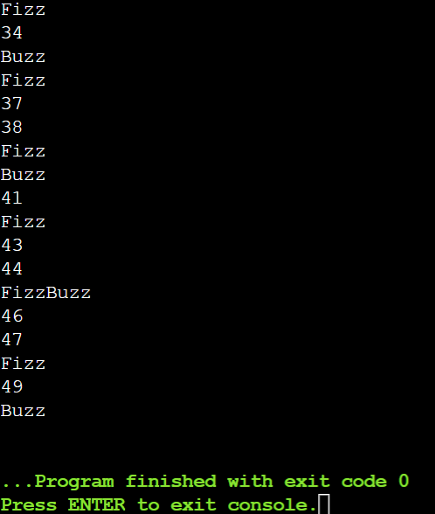

### f)  Develop program accepts string an alphanumeric character (like N89r3u1) and prints the total number of digits in a string and also their sum.

**AIM:**

To develop program accepts string an alphanumeric character and prints the total number of digits in a string and also their sum

**ALGRITHM:**

STEP 1:get the alphanumeric character as a character array

STEP 2 : traverse the array

STEP 3:check if the element ‘s value is 48 to 57 (i.e., ASCII value of 0 to 9)

STEP 4 :if it is between the above value increment count by 1 and add the element with 48 subtracted

STEP 5: print the count , print the sum

**PROGRAM:**

**#include<iostream>**

**using namespace std;**

**int main()**

**{**

**cout<<"enter a alpha numeric string";**

**char arr[20];**

**cin>>arr;**

**int count;**

**count=0;**

**for(int i=0;i<20;i++){**

**if(arr[i]=='\0'){**

**break;**

**}**

**else{**

**count=count+1;**

**}**

**}**

**char arr2[count];**

**for(int i=0;i<=count;i++)**

**{**

**arr2[i]=arr[i];**

**}**

**int sum=0;**

**int count2=0;**

**for(int i=0;i<count;i++)**

**{**

**if(arr2[i]>=48 && arr2[i]<=57){**

**sum=sum+arr2[i]-48;**

**count2=count2+1;**

**}**

**}**

**cout<<"the number of digits is"<<count2<<endl;**

**cout<<"the sum of the digits is"<<sum<<endl;**

**return 0;**

**}**

**OUTPUT:**

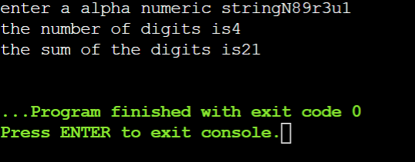

**RESULT:**

Thus the programs for basic problems are executed and the required output is obtained